
This certifies that

(insert name)

Attended the above course on the dates shown below
24th & 25th September 2010
At Weetwood Hall, Leeds
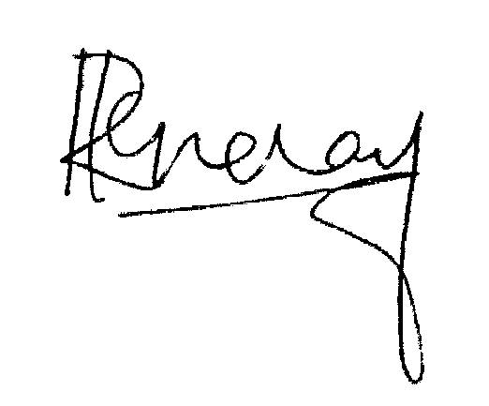
Dr. Ramesh Mehay, Course Organiser (Exit Course)
Programme Director (Bradford Vocational Training Scheme)

BRADFORD VTS EXIT COURSE

